Cloud Computing Data Processing
An innovative cloud application provisioning tool that provides advanced mission resource visibility and cost savings

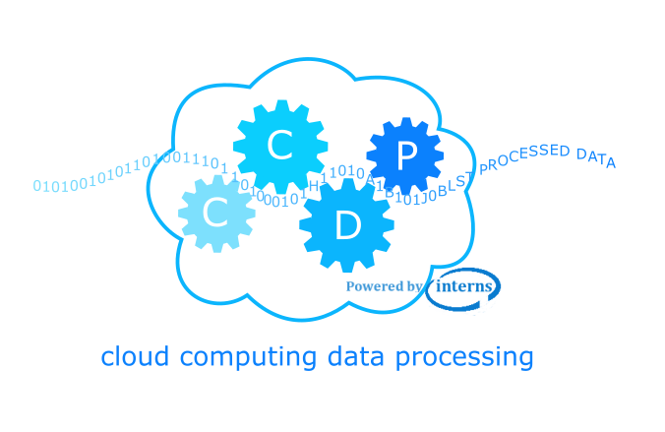

12/10/2018
By: Oscar E. Ganteaume
703.665.7259
Oganteaume@LGSInnovations.com

This document includes data that shall not be disclosed and shall not be distributed, used, or disclosed – in whole or in part – for any purpose other than to evaluate this project and/or product.

Project Overview
CCDP was developed to explore cloud agnostic resource allocation, workload load balancing, and cost containment in anticipation of the governments cloud processing initiatives. In addition to greatly simplifying C2S resource provisioning, saving valuable labor hours, Axios also successfully implemented dynamic load balancing to efficiently distribute mission processing loads. Our CCDP financial results also show up to 50% cost savings in the C2S environment over a stock C2S environment.

Technical Approach
Taking into account the current shortcomings of the AWS services, CCDP’s primarily design goal is to facilitate dynamic resource allocation while hiding its inherent complexity, dynamically “right-sizing” workloads & providing visibility in a cloud agnostic environment.

Load Balancing and Resource Provisioning

CCDP has the ability to start virtual machines only when needed and terminating them when no longer needed. It offers load balancing and auto-scaling features, but also provides a method for customizing the algorithms if warranted by mission circumstances.

CCDP will also allocate a virtual machine to any session that was not able to launch a task due to lack or resources. The VM would be provided by a free agent if available or newly created, to expedite the provisioning process. Tasks can be deployed on three different modes: conventional, serverless, and hybrid running modes.

Conventional Running Mode
Figure 2.1.1-1 depicts a conventional command and control scheme for virtual machines. Users can login to either of two separate web applications and select the tasks to run. The main controller can run either in a resource external to the cloud or as a preconfigured virtual machine. Once the tasks are selected and submitted, the CCDP Engine decides which VM is used to execute the tasks. If the user does not have available resources then a VM is assigned and the tasks are launched accordingly.
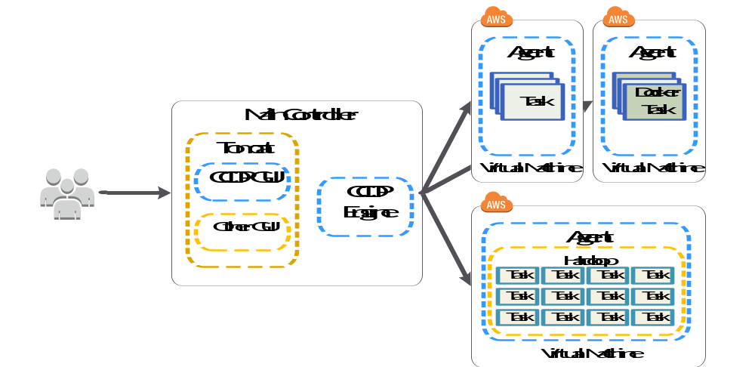
Figure 2.1.1-1 Conventional running mode

The figure above shows tasks running on three different virtual machines. Two of them are configured to run regular tasks as well as tasks running inside docker containers. The third virtual machine uses a different image to execute tasks requiring Hadoop File System. Different images can be added to the system as needed to accommodate different requirements.
Running in this mode means the CCDP Engine is responsible for starting and stopping all the resources. In other words, CCDP has full control of where each of the tasks will be executed, and it ensures there are available resources to satisfy their requirements. This level of control and responsibility is the main difference between the Conventional and Server-less running mode.
CCDP does not place any restriction on the task type or maximum running time when using this mode. This is important when the tasks can be as different as running a Windows desktop or a task within a container. Task requirements can be too diverse to be supported in just one type of instance. Therefore, CCDP supports the use of different images to satisfy such a wide range of possibilities.

Server-less Running Mode
Server-less mode shifts the responsibility for ensuring sufficient resources to execute a task, from the CCDP framework to the cloud server provider. Figure 2.1.2-1 displays a similar scenario as the conventional mode. In this case, the users login to one or more web applications to define and send the tasks to the CCDP engine. The engine send those tasks to a specific gateway endpoint preconfigured to forward those tasks to run as lambda functions. Lambda function execution is an AWS-specific service, but other cloud service providers have similar capabilities. The gateway endpoint invokes a CCDP lambda application that knows how to execute the given task.
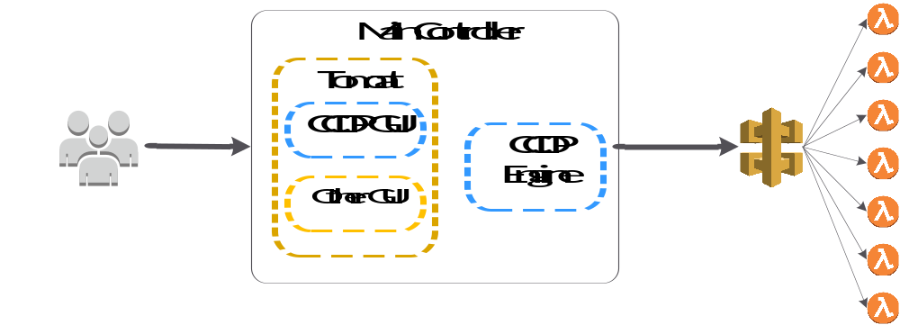
Figure 2.1.2-1 CCDP Serverless running mode
Just as in the conventional mode, the main controller can be part of the cloud service or implemented in an external system.

Hybrid Running Mode
The CCDP framework does not limit users to use one or the other way of the running modes described above. It can also support a hybrid running mode where some tasks are launched on conventional resources and others on function services such as lambda. This type of running mode is shown in figure 2.1.3-1.
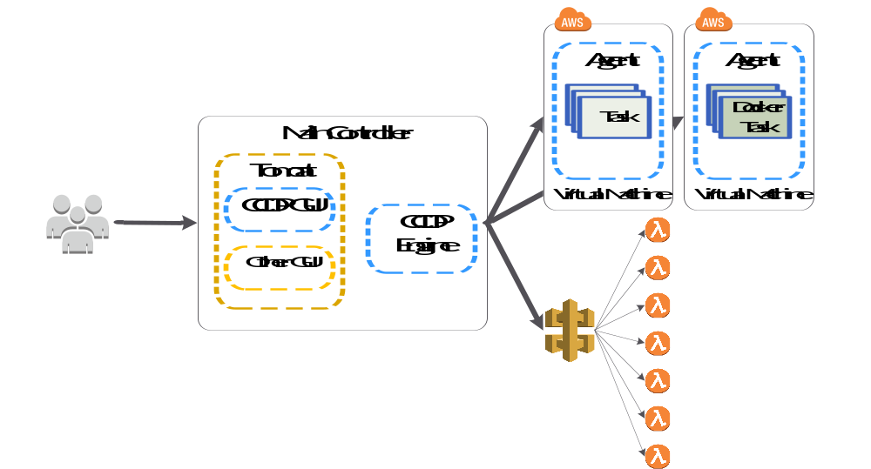
Figure 2.1.3-1 CCDP hybrid running mode

As the tasks are running, they provide feedback on their status, regardless of how they were launched. The engine receives those notifications and uses that information to evaluate the status of the system and to incorporate them into the task allocation algorithm. If the originator of the task provides a “reply-to” field, then the task status information is forwarded to the originator as well. This option becomes important if the task originator needs to display execution feedback or results in their own system. It also gives users the opportunity to disable this feature by just leaving this field blank.
Being able to run tasks in different ways allows users to choose the most effective way to execute their tasks. Users need to make sure the task meets requirements imposed by the server-less services prior to selecting it. For instance, AWS Lambda Services does not allow a task to run longer than five minutes.

CCDP monitors the states of all the virtual machines running within the system grouping them by sessions and terminating those that are no longer needed. As mentioned previously, Zephyrus allows full customization of the conditions in which virtual machines are terminated. This continuous monitoring and task orchestration approach is what enables Zephyrus to save provisioning costs while isolating the application from a cloud service specific configuration.

Resource Visibility

CCDP features a web-based visualization application that allows you to monitor the status of the managed applications, and allows you to quickly determine the health of each session using a near real-time color-coded table. The user can also visualize the health of each virtual machine associated to a session by clicking on the session name.

If the operator is interested in seeing specific tasks then s/he can select a single virtual machine. CCDP loads all the information containing the tasks running on the particular virtual machine. Selecting a particular task displays detailed status information such as start time, run time duration, and where it’s running, et cetera.

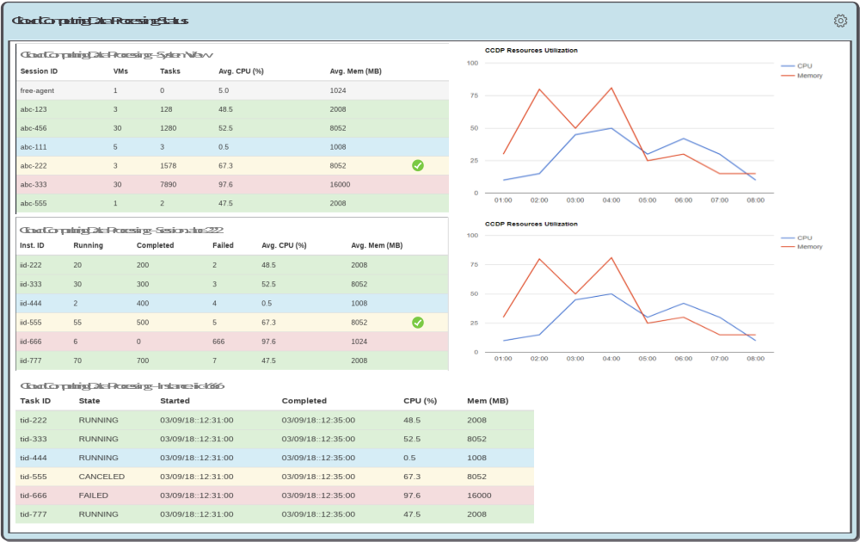
Figure 2.1.4-1: Resource Visibility

Current Status/Roadmap

Status
The current status of the CCDP IR&D can be divided into the following categories:

- Back-end Framework Development
  - Patent submitted for the cloud management portion
  - Selected to present the idea to a national customer, waiting for their response to whether or not funding will be provided to productize it
  - Incorporated Docker as a “cloud service provider” for quick turnaround environments
- Front-End GUI Development
  - Tasking submission and management GUI partially developed
  - Need to improve management as well as tasks handlers components management
  - Improvements to the GUI is being done on a need basis
- Tools Integration
  - NiFi partially integrated
- Testing
  - Added better unit testing
  - Enabled the use of Docker to act as cloud provider for faster testing

Roadmap
CCDP has been developed as a prototype or proof of concept and therefore it does not have the maturity to be productize. The following list is a summary of what needs to be done in order to greatly improve its functionality as well as stability:

- Develop a web-based configuration page
- Optimize current configuration approach
- Replace current heartbeat monitoring/reporting approach
- Improve task and thread management web based tool

Conclusion
Private institutions as well as government agencies are transitioning towards virtual environments. Conversations with our national customers have given us the opportunity to hear their concerns about such transition. One of their biggest concern involves operation costs as it has been greater than maintaining their own datacenter. The main reason of this high cost of operation is due to the fact that engineers provision resources based on the worst case scenario. Such over provision incurs in costs whether or not those resources are being used or not. A tool facilitating the management of those resources will help reduce operation costs while giving us more insight of the customer’s needs. The continual investment in cloud environments are key to give LGS a technological advantage over our competitors in this area.

